GENERAL INFORMATION:

The obligation to declare cash on entering or leaving the European Union is part of the European Union strategy to prevent money laundering and to fight terrorist financing.

You must complete this form if you are entering or leaving the European Union and carrying 10 000 EUR or more in cash (or the equivalent in other currencies) [Regulation (EC) No 1889/2005, article 3 (1)] and Section 41 of the Act no. 253/2008 Coll., on selected measures against legitimization of proceeds of crime and financing of terrorism, as amended.

According to Regulation (EC) No 1889/2005 article 2 (2) you have to declare:

a) bearer-negotiable instruments including monetary instruments in bearer form such as traveler's cheques, negotiable instruments (including cheques, promissory notes and money orders) that are either in bearer form, endorsed without restriction, made out to a fictitious payee, or otherwise in such form that title thereto passes upon delivery and incomplete instruments (including cheques, promissory notes and money orders) signed, but with the payee's name omitted;
b) Currency (banknotes and coins that are in circulation as a medium of exchange).

In the event of false, inaccurate or incomplete information, the signatory will be considered not to have fulfilled the above obligation and is liable to penalties or have cash detained or confiscated by the competent authorities under Section 50 of the Act no. 253/2008 Coll., on selected measures against legitimization of proceeds of crime and financing of terrorism, as amended and Regulation (EC) No 1889/2005, article 3 (1) and 9(1). Information and personal data shall be recorded and processed by the competent authorities [Regulation (EC) No 1889/2005, article 5 (1)] and shall be made available to the authorities referred to in Article 22 of Directive 2005/60/EC. Data will be dealt with in accordance with Section 42 of the Act no. 253/2008 Coll., on selected measures against legitimization of proceeds of crime and financing of terrorism, as amended and Act no. 101/2000 Coll., on personal data protection and on the amendment of certain other acts, as amended.

EXPLANATORY NOTES

All parts in white must be completed in capital letters and dark ink (use, where requested, one letter/number per box) by the declarant; parts in grey are for the competent authorities.

1. Entering EU and Leaving EU
Tick the box 'Entering EU when you are entering the European Union on a journey that started outside the European Union
Tick the box 'Leaving EU when you are leaving the European Union on a journey that will end outside the European Union
You need to make a declaration on entering and on leaving, even if you are only in transit. Be aware that you can be required to make further declarations on other national border crossing points of your travel.

2. Personal details of the declarant
Enter the details as they appear in your ID-Document (the competent authorities can make a copy of your ID and/or travel documents).
Personal Number: enter your personal tax identification number, personal social security number or similar unique personal identification number.

3. Personal details of the owner
If you are not the owner of the cash give details of the owner. The owner can be a natural person or a legal entity. Tick the appropriate box and fill in the details. Ensure to enter the Value Added Tax (VAT) number when known.
If there is more than one owner, enter the details of the other owners on annexed documents. For this purpose extra copies of the declaration form can be used. All information will constitute one declaration. All annexed pages must be signed.

4. Details currency/bearer negotiable instruments
Complete the exact amount per currency and per type of bearer negotiable instruments. Provide this information in the following format: example 10 358 EUR or 17 501 US DOLLAR or 19 471,18 BRITISH POUNDS or traveler's cheques for a value of 15 000 EUR.
As a general rule all financial instruments that can be physically transferred anonymously from one person to another are included in the definition of cash. You can find the definition of cash under 'general information' on top of this page.

5. Origin and intended use of the cash / monetary instruments
Origin: indicate where the cash declared comes from e.g. an inheritance, savings, from a sale of property, etc.
Explain briefly the intended use: e.g. acquisition of property, investment etc.

The intended recipient can be a natural person or a legal entity (e.g. a company). Tick the appropriate box and fill in the details.
Ensure to enter the Value Added Tax (VAT) number when known.
If there is more than one intended recipient, enter the details of the other intended recipients on annexed documents. For this purpose an extra copy of the declaration form can be used. All information will constitute one declaration. All annexed pages must be signed.

6. Transport details
Tick "Air"/  on entering/leaving by aircraft. Provide the flight number or the registered number of the aircraft under Box 'Reference number'.
Tick "Sea"/  on entering/leaving by sea. Provide the shipping line details under Box 'Reference number'.
Tick "Road"/ 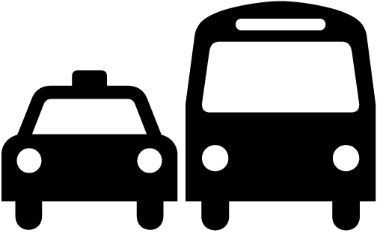 on entering/leaving by any kind of motorized road vehicle (car, bus, truck, motorcycle etc.). Provide the official registration number and country code of the vehicle under Box 'Reference number'.
Tick “Rail”/  on entering/leaving by train. Provide the train type and the train number under Box 'Reference number'.
Tick "Other" if none of the other transport methods were used (e.g. pedestrian traffic, bicycle).

7. Signature of declarant
Sign the declaration and fill in the date. You can ask for an endorsed copy of your declaration.

